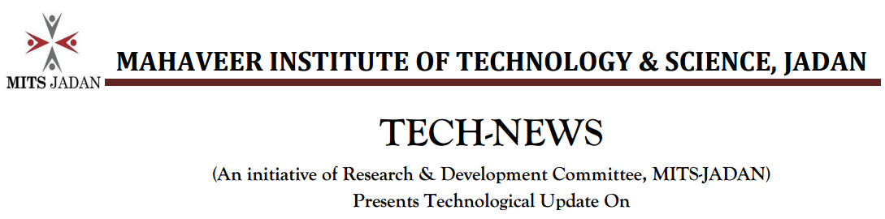
Microbial desalination cell technology

By

Dr. Arun Sharma*, Deshmukh S. Solanki, Hitesh Parihar
Faculty, Chem. Dept.
Correspondence author email. arun.sharma@mitsjadan.ac.in
Date: 9/11/2016

Introduction:

The microbial desalination cell (MDC) is a newly-developed technology which integrates the microbial fuel cell (MFC) process and electrodialysis for wastewater treatment, water desalination and production of renewable energy. Due to free energy requirements and environmentally friendly technologies, MDC recently received considerable attention for desalination and wastewater treatment.

Keywords: Desalination; Wastewater; Microbial desalination cell

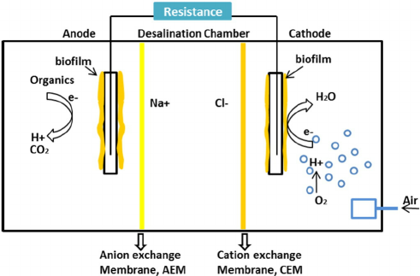

Schematic representation of microbial desalination process

Highlights for R & D aspects:
- The issues of scale-up and practical limitations of MDCs are also need to be addressed.
- Alternate designs for wastewater treatment plants with MDCs are required to be evaluated.
- Main challenges for using MDC in seawater desalination will discussed for R & D.
- Current challenges in MDC scale-up will be examined and presented.

